**TEMASEK POLYTECHNIC**

**SCHOOL OF INFORMATICS & IT**

**DIPLOMA IN IMMERSIVE MEDIA & GAME DEVELOPMENT**

**AY2025/2026 APRIL SEMESTER**

**GADV (CGE2C25)**

**Unity Physics Worksheet**

To see the additional comments and resources, make sure you select **All Markup** in the **Review/Tracking** pane

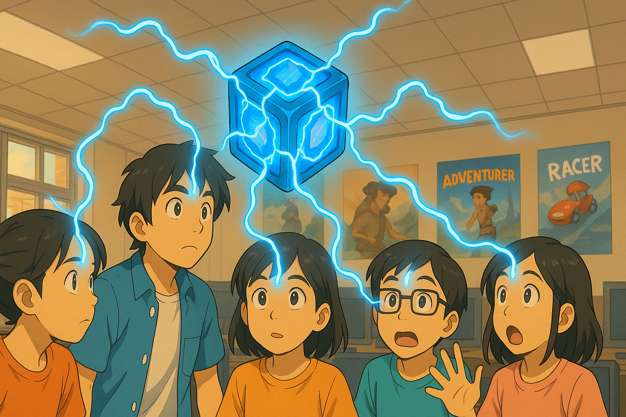

**QUESTION 1 (basics of Unity physics)**

1. What is the core responsibility of a RigidBody component?
2. Why is the Pong game paddle mentioned as an example of an object whose rigidbody’s isKinematic property would be set to true? Hint: what controls the paddle movement?
3. Explain what the rigidbody **constraints** are for. Give ONE example of when this might be useful.
4. Watch [this video](https://www.youtube.com/watch?v=ixM2W2tPn6c).
5. What is one major problem with using the Translate function to move an object?
6. Why is the physics-based code put in the FixedUpdate function and not in Update?
7. What are the THREE different methods covered in the video to move an object using physics?

Explain how each method works.

**QUESTION 2 (Colliders)**

1. What is the core responsibility of a collider component?

1. Look at the question in [this forum post](https://forums.oculusvr.com/developer/discussion/59641/problems-with-fast-moving-object-collision-in-unity-table-tennis-racket-vs-ball). What is the solution to the problem? Do some research to explain why this is the solution. Draw a diagram to illustrate your answer.
2. What is the difference between collision *detection* and collision *resolution*?

**QUESTION 3 (Joints)**

1. What type of joint is used in the video? According to Unity’s documentation, what does this joint do? Give an example of how the joint could be used in a game.
2. What other types of joints are there? Briefly explain what FOUR of these joints does (do NOT include the type of joint you answered for part a above), and give an example of how each one might be used in a game.

**QUESTION 4 (Physic Material)**

1. What is the difference between dynamic friction and static friction?
2. Find a game that you have seen online or played yourself where physics is a core game mechanic.

You must:

* give a brief description of the game
* briefly explain how physics is used
* explain why physics is important
* include a relevant screenshot of the game

**QUESTION 5 (CharacterController)**

1. According to the video, the built-in CharacterController component does not interact with physics. So, a CharacterController does not react to gravity, and when a CharacterController collides with another object with a rigidbody it does not have any force added to it (like when being hit by a cannonball throws an object across the scene).

What gameplay-related reason(s) can you think of to explain why the CharacterController component was designed this way?

1. To make a character controlled by a CharacterController experience gravity while moving, two options are given in the video. What are these?
2. Create a Unity scene with a capsule game object with a CharacterController. The script below will make the character jump when the space bar is pressed.

Fill in the missing parts of the code, then copy the whole Character class code here. Make sure it is formatted properly!

**QUESTION 6 (Constant Force component)**

1. For the Constant Force component, what is the difference between the Force and Relative Force properties, and between the Torque and Relative Torque properties?
2. When the cube is in the air with a Force X of 1, it moves, but when it falls to the plane, it doesn’t move.

Why not?

1. An object has a constant force applied along its local positive Z axis. What happens to the object’s speed over time?

Explain your answer.

**QUESTION 7 (Forces)**

1. Paste your **Player** class code here. Make sure your code is readable, properly formatted, and commented.
2. Paste your **Kick** function code here. Make sure your code is readable, properly formatted, and commented.
3. What does the upwardsModifier argument of AddExplosiveForce do?

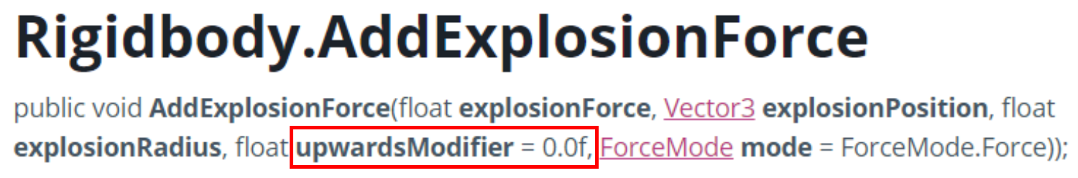

**QUESTION 8 (Forces cont.)**

1. What are the FOUR different values for ForceMode? Explain what each value does.
2. Paste your code for firing the sphere here.
3. Paste your code for rotating the beam here.

**QUESTION 9 (Collision event-handling)**

1. Paste your code for **CosmicCube.cs** and **Orb.cs** here. Make sure your code is readable, properly formatted, and commented.

**QUESTION 10 (Raycasting)**

1. Paste your completed code for the CheckLineOfSight() function here.
2. When checking for a hit using a ray, the code below is used:

if (Physics.Raycast(transform.position, vec, out hit, vec.magnitude))

Why is **vec.magnitude** used for the length of the ray?

1. The layers dropdown in the Inspector has an entry for **Ignore Raycast**.

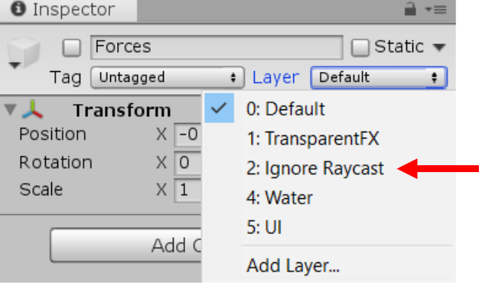

What does this mean? Why do you think this is important? Give an example.